**Docker Task -01  
==============**

**1) Setup a virtual machine using Ubuntu image.**

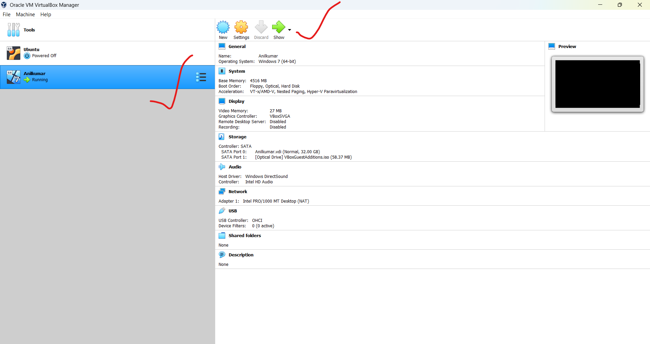

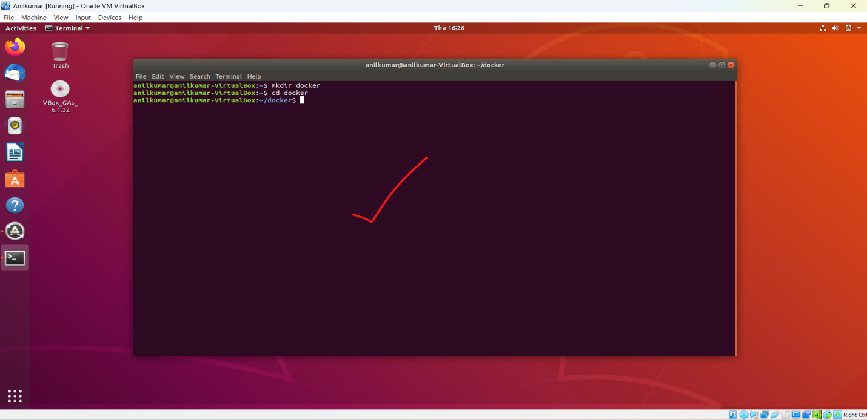

**2) Install docker on ec2.**

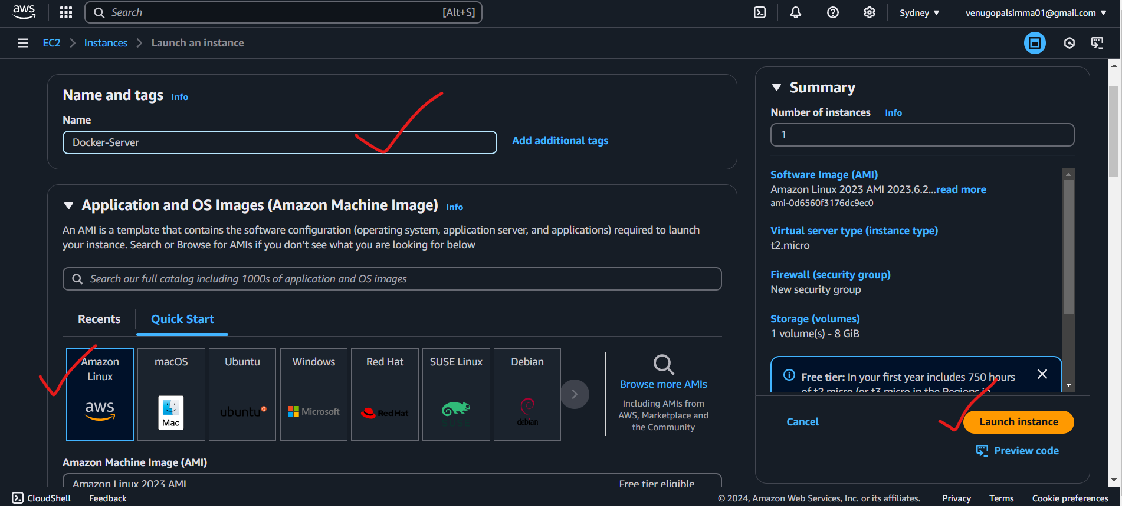

**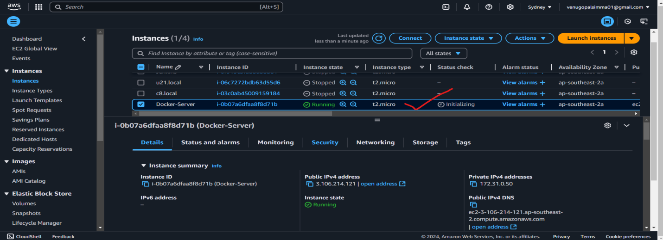  
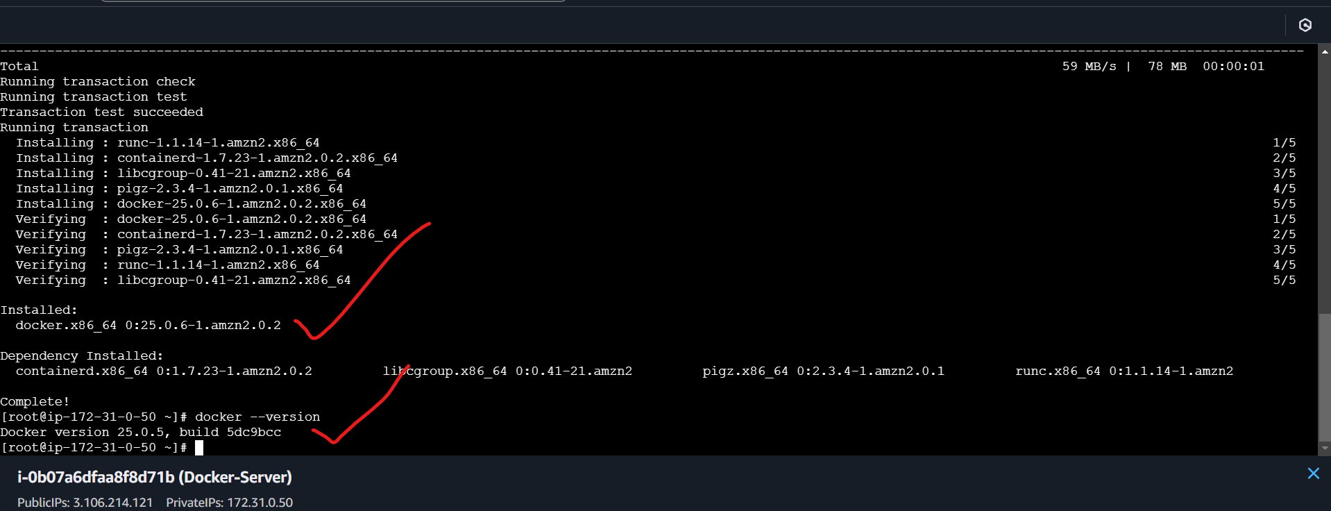**

**3) Pull 5 docker images.(nginx,apache tomcat,ubuntu,jenkins,sonarqube)**

**Nginx: docker pull nginx**

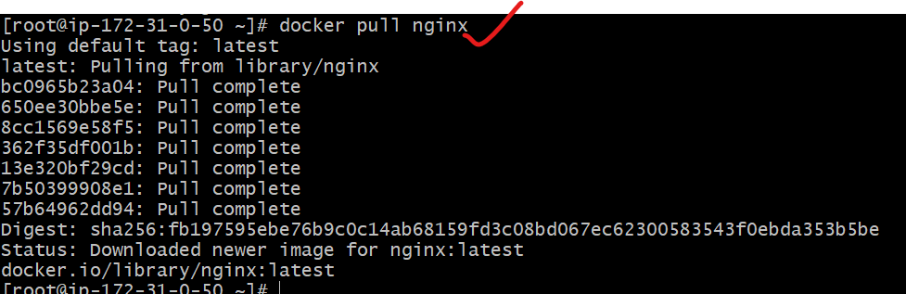

**Tomcat: docker pull tomcat**

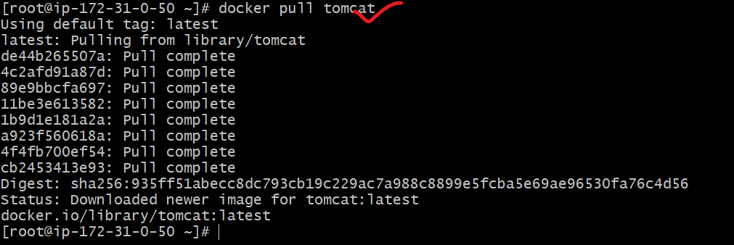

**Ubuntu: docker pull ubuntu**

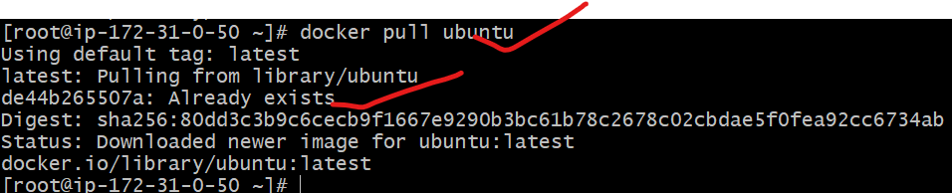

**Sonarqube: docker pull sonarqube**

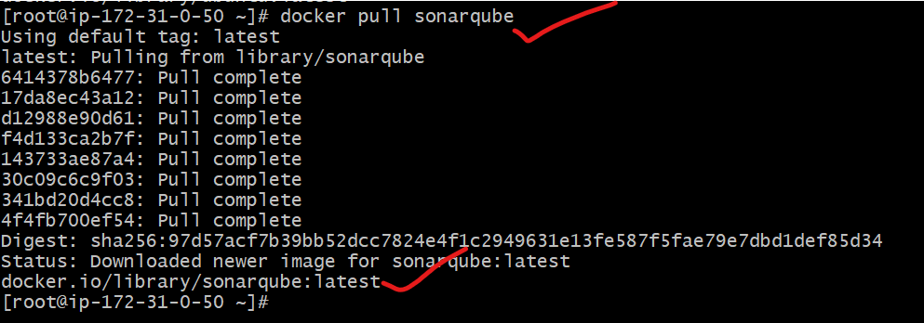

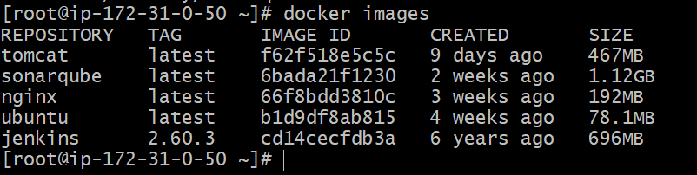

**4) Run nginx container and expose on port 81.**



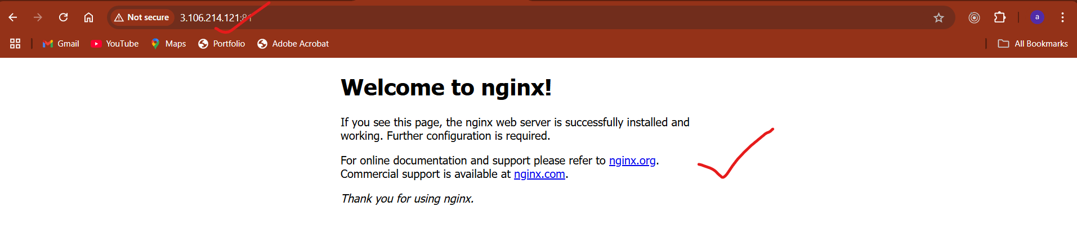

**5) Delete the apache tomcat image from local.**

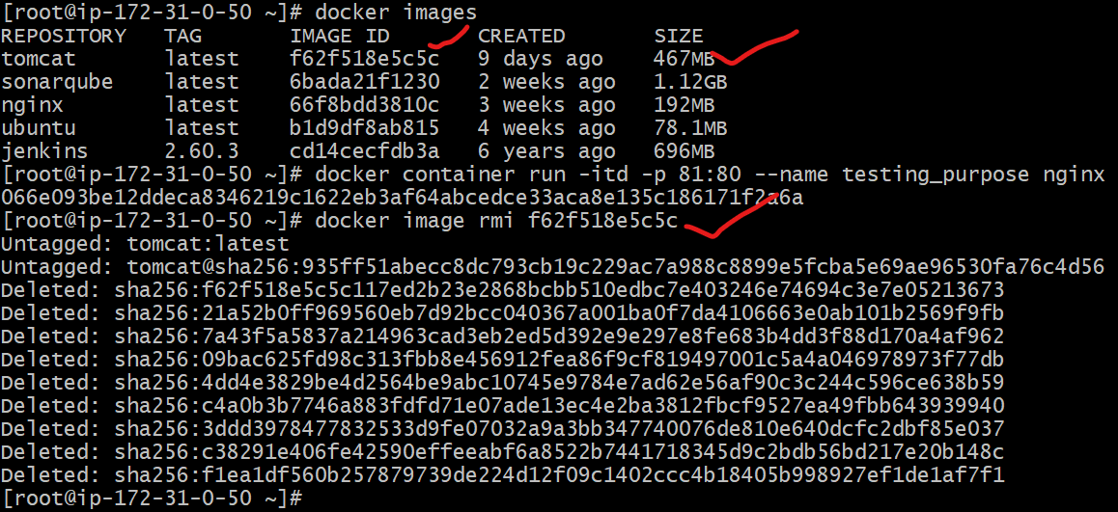

**6) Inspect the jenkins image,sonarqube image.**

**Jenkins image:**

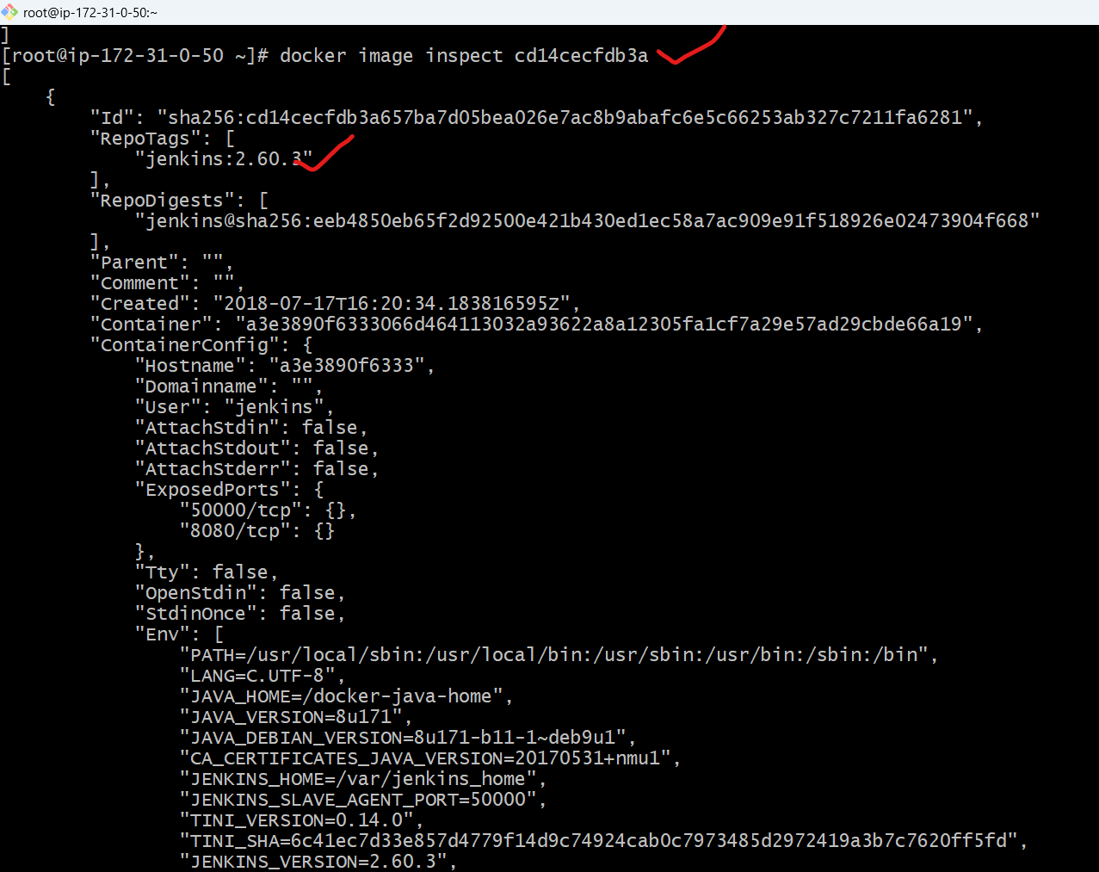

**Sonar image:**

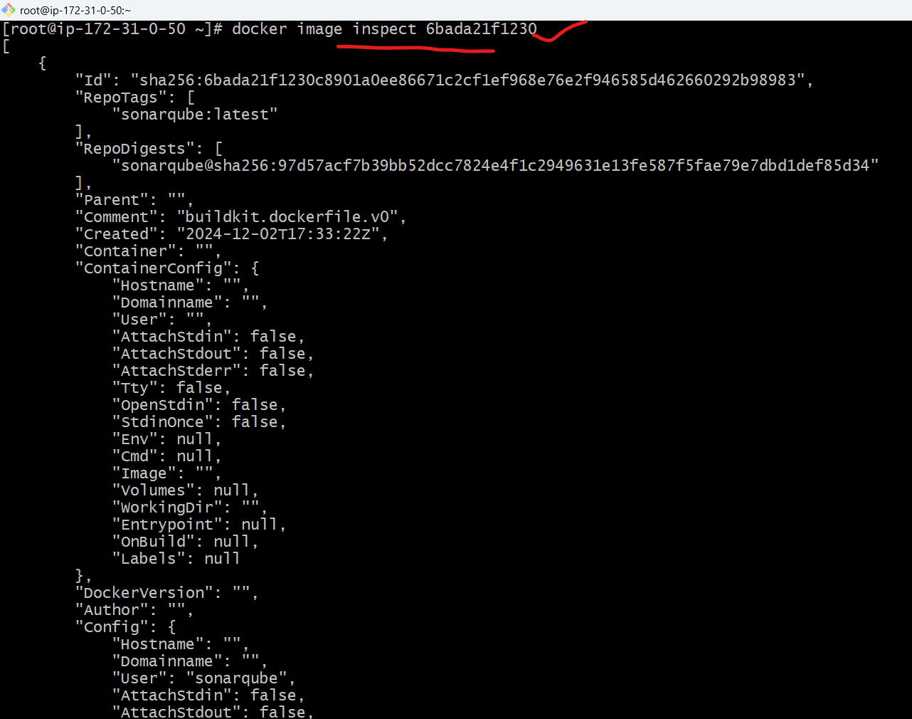

**7) Run jenkins contianer and run one sample job.**

